

Final Project

CPS3500: Programming World Wide Web Server

|  |  |
| --- | --- |
| Project Name: | Campus Map |
| Student Name: | Chun Chen (Dave) |
| Student ID: | 1234930 |
| Lecture: | Dr. Hemn Barzan Abdalla |

Spring 2025

Table of Content

1. Introduction
2. Proposed problem
3. Proposed solution
4. Conclusion
5. References

# 1. Introduction

This website provides a visual and interactive campus navigation tool, featuring a login and registration page, a main map interface, and detailed pages for selected buildings.  
On the main map page, users can quickly identify building names, relative positions, and images through interactive SVG elements.  
Additionally, users can access detailed building pages by clicking on the corresponding areas in the SVG map or by using the navigation bar.

# 2. Proposed Problem

The website requires a functional database to support user login and registration for accessing the campus map system.  
In addition, the main map interface needs to offer sufficient interactivity and ease of use, allowing users to quickly understand building positions and names.  
To enhance the overall experience, each building should also have a dedicated page that provides detailed information and images.

# 3. Proposed Solution

The whole System uses the following structure:

CampusMap(Root)------index.html(for sign in and signup)

|---campusMap.html(for the main map)

|---BusinessFaculty.html(detail of CBPM)

|---ComprehensiveStadium.html(detail of the Comprehensive Stadium)

|---GHKBuilding(detail of the GHKBuilding)

|---db.php(get user data from database)

|---signup.php(insert new user data through db.php)

|---login.php(use the user data from db.php to check in)

|---logout.php(clear the login status)

|---imgs(contains images in the building page, and some background images)

|---map(contains images needed in the main map, and some background images)

|---Style.css(contains all style we need)

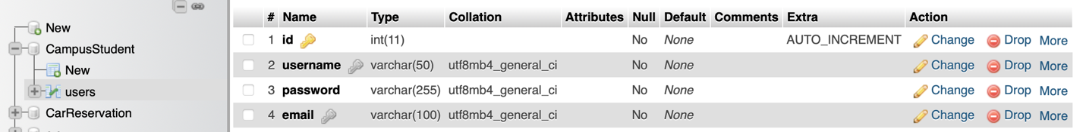

(Fig.1)

This project uses a MySQL database. The database is named **CampusStudent**, and it contains a table named **users**, which includes 4 fields: id, username, password, and email. (Fig.1)

**The Login and Signup page(index.html):**

The start page look like below(Fig.2):

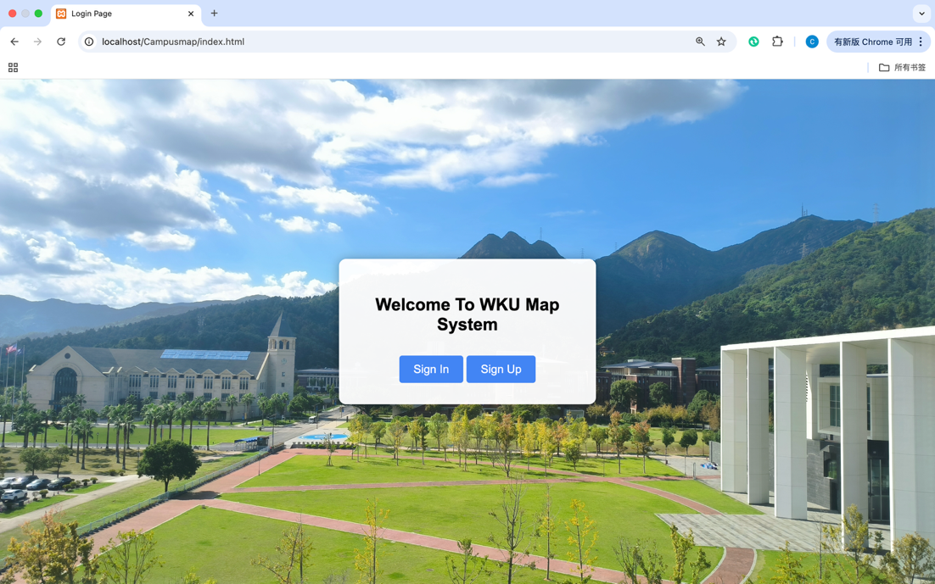

(Fig.2)

If we click Sign in or Sign up, this form will change to a sign-in form(id = signin-form) or a sign-up form(id = signup-form)(Fig3, 4, 5).



(Fig.3)

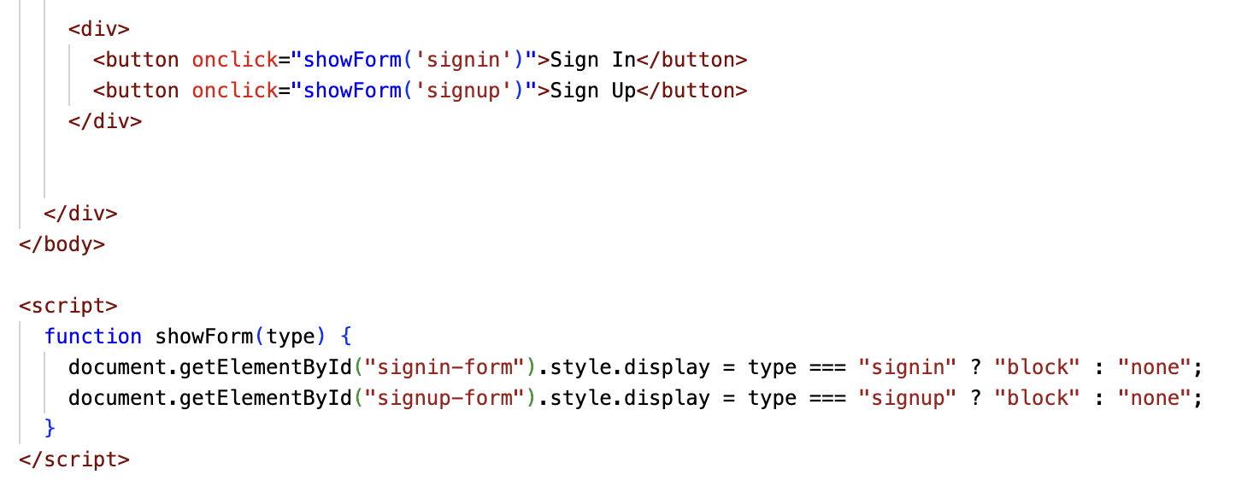

(Fig.4)

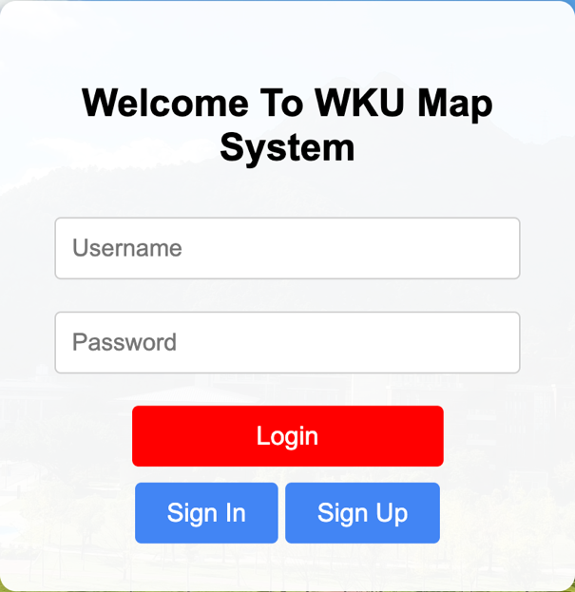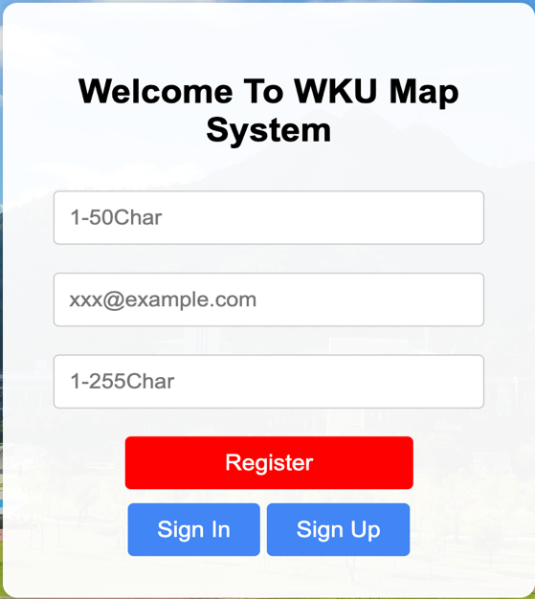

(Fig.5) left is Sign In, right is Sign Up

The data we be submitted to login.php or signup.php(Fig.3, 6),





(Fig.6)

The login.php file uses the PDO object from db.php to retrieve user information from the database. If the user exists, it compares the input password with the one stored in the database.  
The signup.php file uses an SQL INSERT statement to add new user information (username, email, password) into the users table via the same database connection provided by db.php.(Fig. 7, 8, and 9)

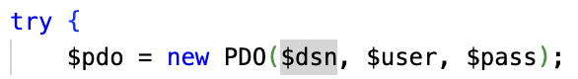

(Fig.7)db.php

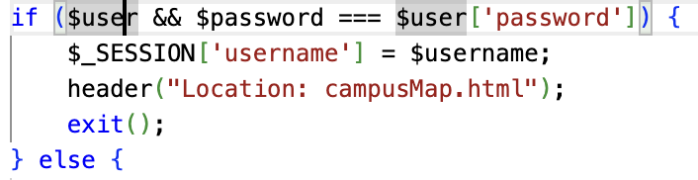

(Fig.8)login.php



(Fig9)signup.php

**The Main Map page(CampusMap.html):**

use figma form **SVG** picture with id(Fig.11) and translate into html code(Fig.10) and use in(Fig.12):



(Fig.10)

d=”****” describes the path direction and length, fill=”****” describes the internal color, fill-opacity”****” describes the transparency, and stroke is the border color.

We also use the code below to ensure that the browser can correctly interpret and render SVG



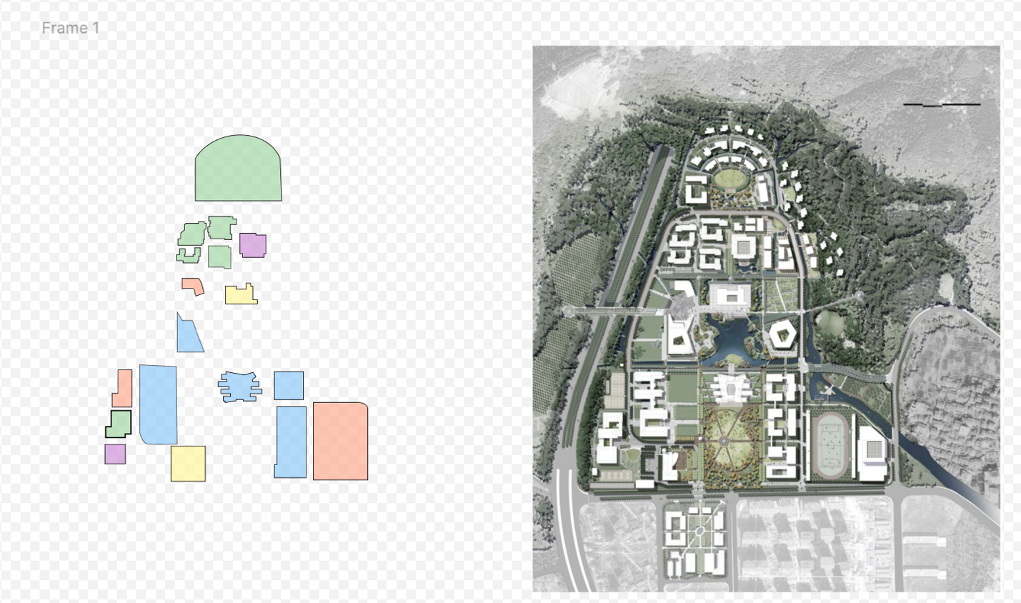

(Fig.11)figma SVG 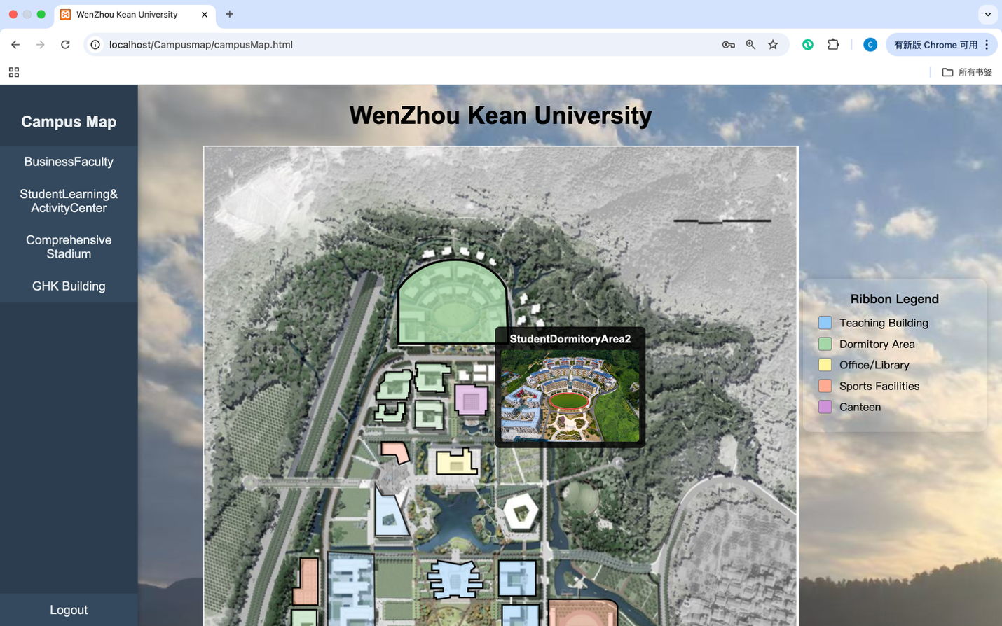

(Fig.12)

We add eventListener to achieve interactive functions

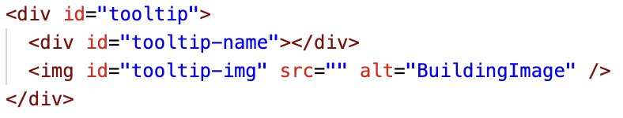

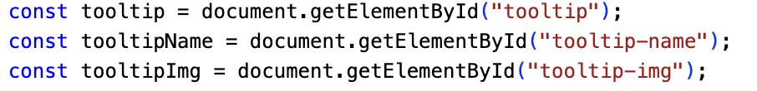

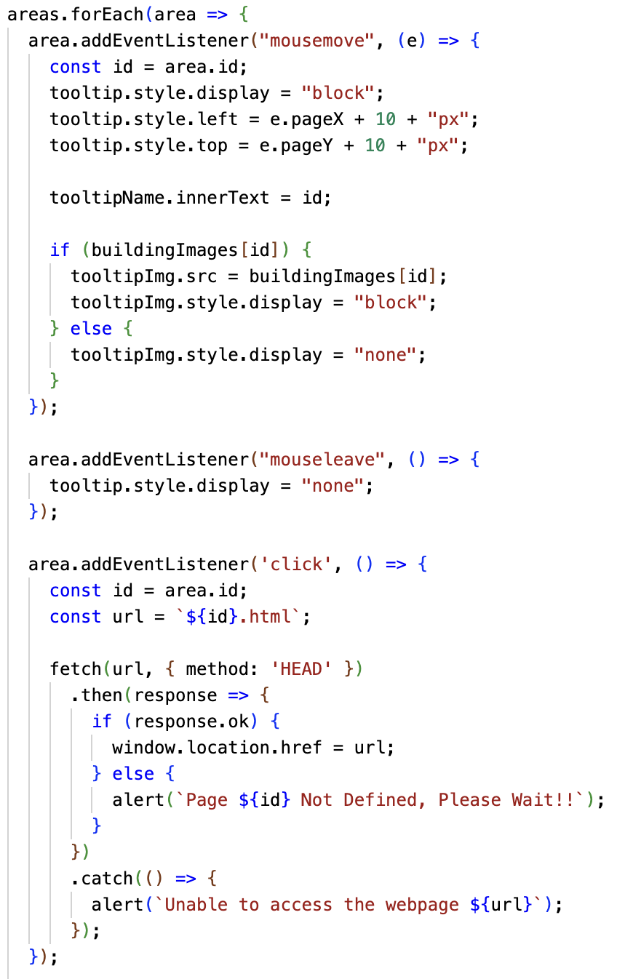

(Fig.13)

If the pointer passes through the SVG with the corresponding id, the corresponding image and id will be displayed.(Fig13)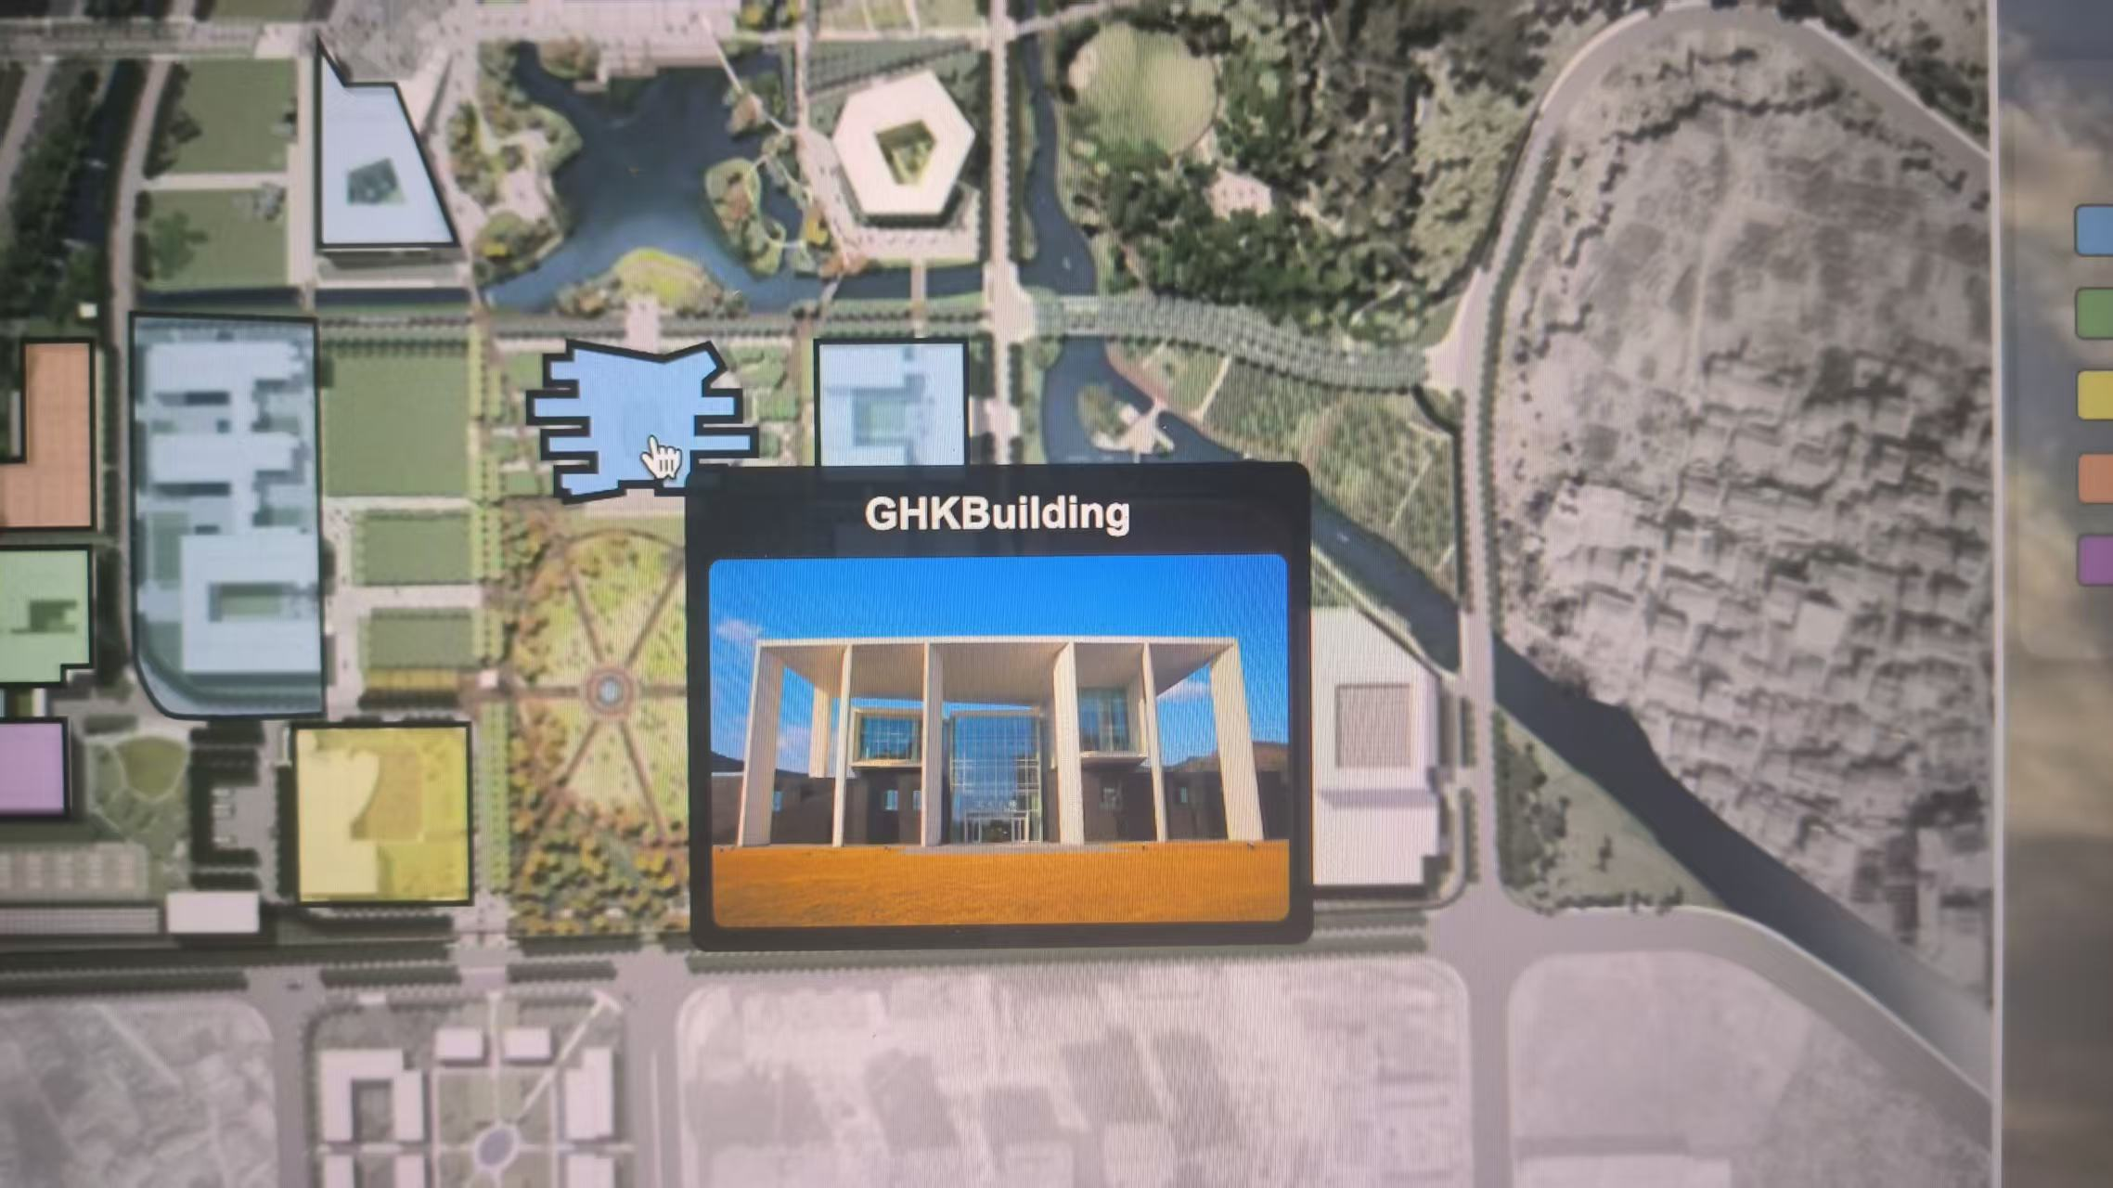

(Fig.14)

And if we click the SVG, it will jump to the corresponding building page see below(GHKBuilding.html). All building pages use the same framework and CSS:

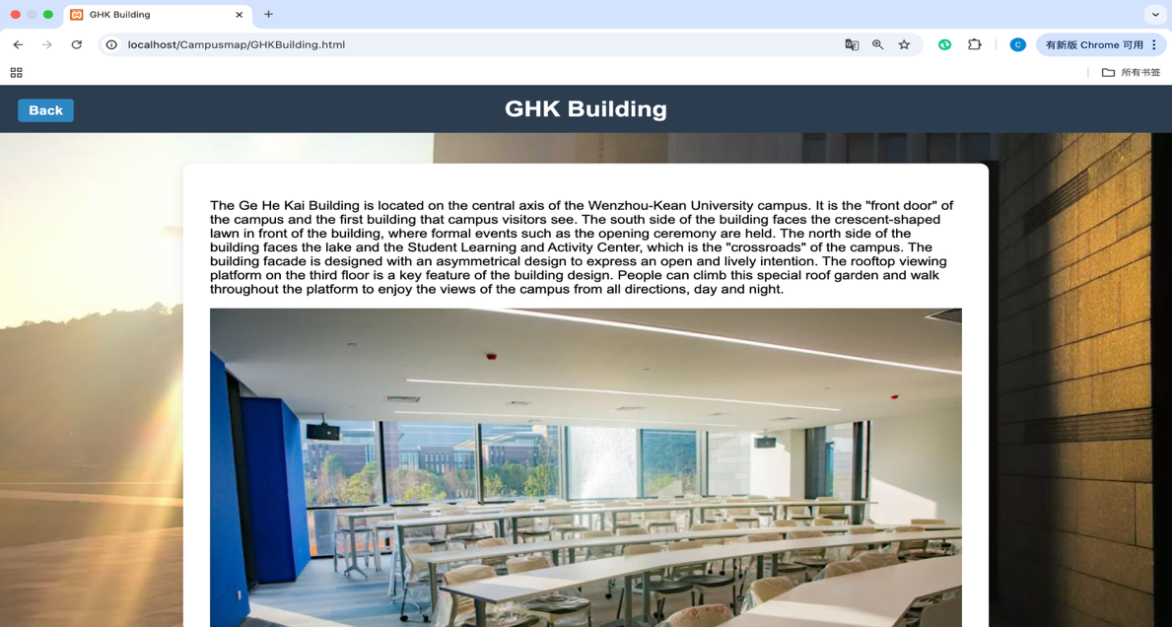

We can also jump to the same page by clicking the building name corresponding to the sidebar on the left side of the webpage.(Fig. 15)

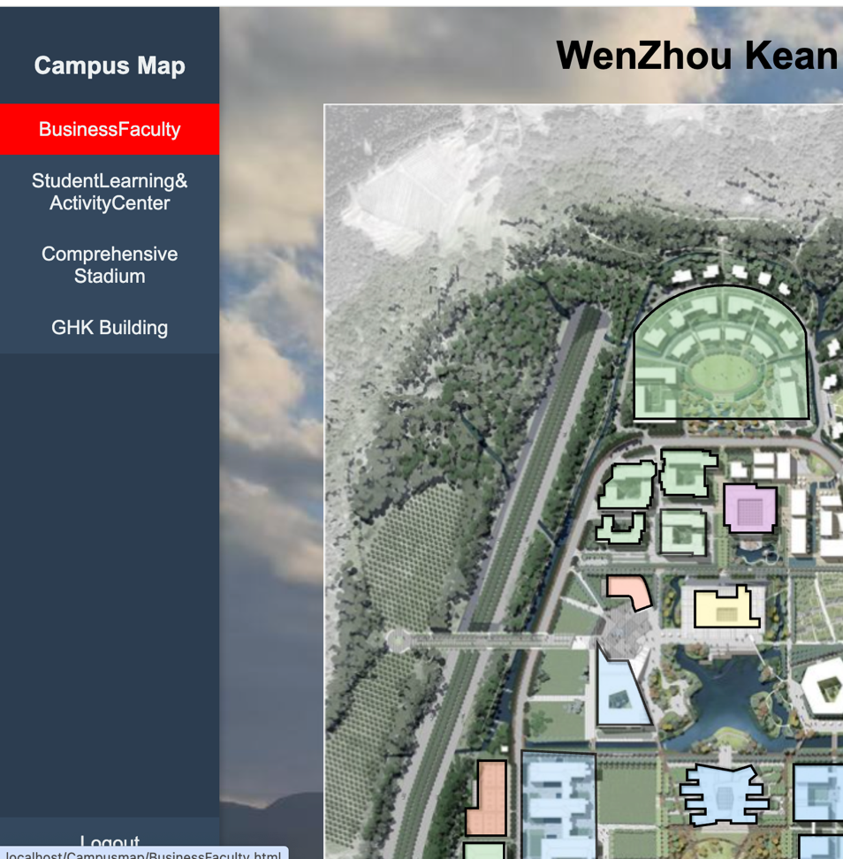

(Fig.15)sidebar

We also added a Ribbon Legend to increase visualization, and matched the corresponding functional areas with the colors on the graph.(Fig.16)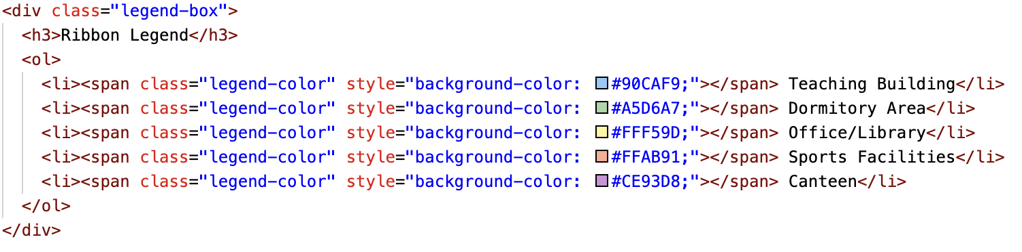

(Fig.16)

**About Style.css:**





(Fig.17)

For every CSS block(Fig.17) we have already added comments to describe function, For example:  
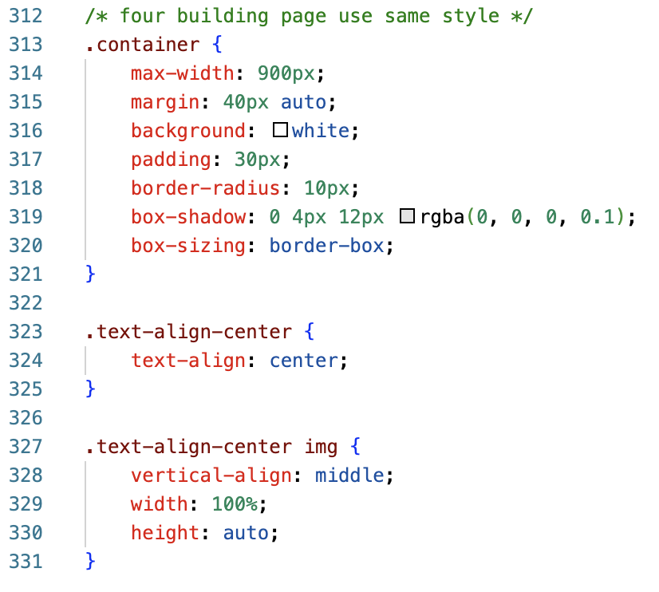

(Fig. 18)

This block(Fig.18) describes four Building pages that use the same framework(Fig.19)

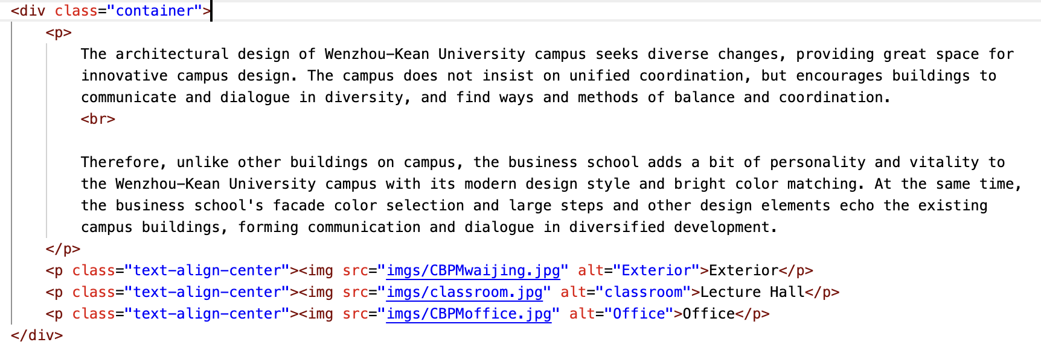

(Fig. 19)

# 4. Conclusion

This project successfully implements an interactive campus map system that combines user authentication and dynamic visual navigation.  
Users can sign in or sign up through a unified login interface, which is connected to a MySQL database using PHP (via db.php) to store and verify account data securely.  
Once authenticated, users are redirected to the main campus map page, where interactive SVG elements allow them to explore building names, view images, and access dedicated building information pages with a single click.  
Each building page follows a consistent design framework and shares a unified style defined in style.css.  
The sidebar navigation and color-coded legend further enhance usability and provide intuitive access to specific areas of the campus.  
Through this system, the project meets its primary goals: improving navigation clarity, enabling easy user access control, and presenting detailed building information in a user-friendly format.  
It demonstrates the integration of front-end visualization with back-end data handling in a clean and modular structure.

# 5. References

* Figma was used to design and export the interactive SVG image.
* The standard from <http://www.w3.org/2000/svg> was used to ensure correct parsing and rendering of SVG elements in the browser.
* A users table was defined using MySQL to support login and registration.
* Visual Studio Code was used as the primary code editor and development environment.